**Common Voice – Advocacy Video**

The AIDS epidemic is at a critical point. A remarkable, decades-long global effort has given us the capability to end AIDS as a public health threat. However, the global political will to end AIDS is weakening, raising the risk of a major resurgence of the epidemic in the 2020s, with tens of millions of lives at stake.

The Common Voice Initiative is creating a video advocating a global re-commitment to ending AIDS. The video will incorporate the use of the Common Voice pledge in a variety of settings from diverse religious traditions around the world. We would like to include your place of worship in this video. If you are able to help, please follow the instructions below for preparing, recording, and submitting the video. We plan to release the video on World AIDS Day (December 1). In order to include your video, we will need it no later than November 15.

Thank you in advance for your help in ending AIDS.

For more information, please visit our website at [www.CommonVoiceAIDS.org](http://www.CommonVoiceAIDS.org), or contact David Barstow at [drbarstow@empactafrica.org](mailto:drbarstow@empactafrica.org).

*“As leaders and followers of many of the world’s great religions, we are speaking together with a common voice to urgently demand that the world re-commit to ending AIDS.”*

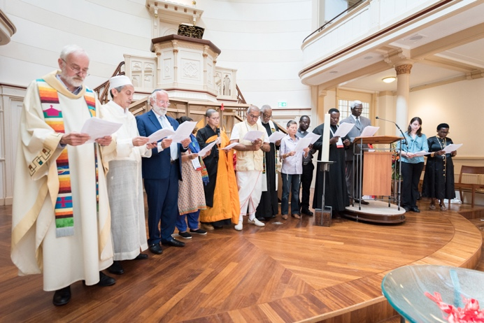

A diverse group of religious leaders led a responsive reading of the Common Voice pledge at a special worship service during the 22nd International Conference on AIDS in Amsterdam.

**Common Voice – Advocacy Video Instructions**

**Preparation:**

1. The English version of the Common Voice pledge is at the end of this document.
2. If English is not the preferred language for your place of worship, please translate the statement into your preferred language.
3. Please arrange with your worship leader and the congregation to read the statement responsively during a worship service.
4. If it is impractical to do the statement responsively for any reason, feel free to use the statement in some other form. For example, have two leaders read it, one reading the parts called “Leader” and one reading the parts called “Response.” You could do the “All” parts as “repeat after me”, or have the congregation simply respond with “Amen.”

**Recording the Video:**

1. 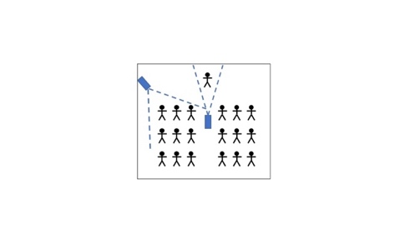Have at least two people record the video on the day of the reading, using either video cameras or phones. One camera should be focused on the leader, relatively close. The other camera should have a wide view of the congregation from the front. The diagram illustrates one possible arrangement, but if your worship center has a different layout, feel free to use a different arrangement.
2. 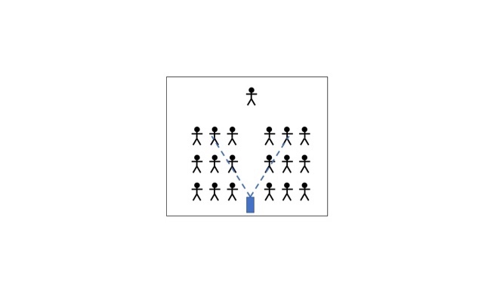If you have only one camera, locate it partway back in the congregation so you can see the leader clearly as well as the backs of some of the congregation members. The diagram illustrates one possible arrangement, but feel free to use a different arrangement.
3. 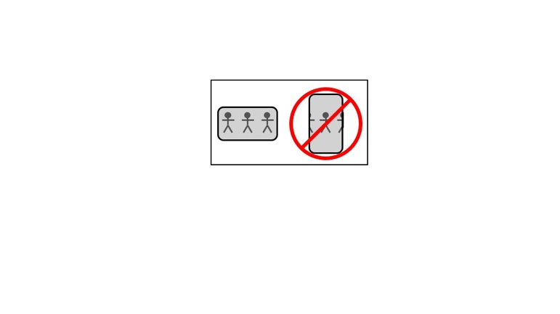If you use a phone, be sure to have the phone turned sideways and record the video horizontally, not vertically.
4. Once the camera or cameras are in place, record the entire responsive reading with each camera. Start the recording at least 30 seconds before the reading, and stop the recording at least 30 seconds after the reading is over. Do not move the cameras at all during the reading.
5. If you have a third person with another camera or phone, that person can walk around the place of worship and record close ups of members of the congregation during the responsive reading.
6. In addition to the two videos of the responsive reading, please also record a short video of some activity that shows the spiritual nature of the event, such as a hymn or chant.
7. 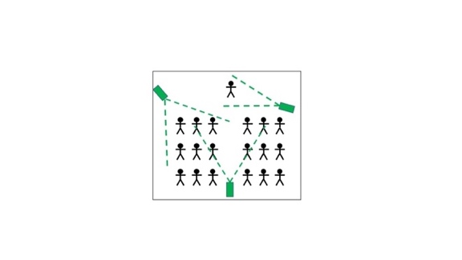Also, please take three still pictures, one of leaders from the front of the stage, one of the congregation from the front, and one that shows both the leaders and the congregation from the back. The diagram shows examples of a good selection of still pictures.

**Submitting the Video:**

1. We will need all of the videos, plus any still pictures, plus the translation if you made one.
2. Please send an email to David Barstow at [drbarstow@empactafrica.org](mailto:drbarstow@empactafrica.org). He will send you a website link for uploading the files.

*Thank you again for your help!*

**Common Voice Pledge**

*The AIDS epidemic is at a critical point. A remarkable, decades-long global effort has given us the capability to end AIDS as a public health threat. However, the global political will to end AIDS is weakening, raising the risk of a major resurgence of the epidemic in the 2020s. Strong advocacy by religious voices is vital to ensuring that the world perseveres and finally brings the AIDS epidemic to an end.*

**Leader:** As leaders and followers of different religious traditions, we are speaking together with a common voice to urgently demand that the world re-commit to ending AIDS.

**Response:** We demand that the world’s leaders take strong actions now and in the future to ensure that this epidemic is finally brought to an end.

**Leader:** We are speaking with a common voice because our diverse religious traditions share many sacred values.

**All:** We share a belief in the inherent value and worth of all human beings.

**All:** We share a conviction that all human beings must be treated with dignity and respect.

**All:** We share a commitment to relieve human suffering.

**All:** We share a responsibility to reach out to the marginalized and to protect the vulnerable.

**Leader:** Although HIV and AIDS affect different people, regions, and social groups differently, we know that the epidemic affects the entire human community.

**Response:** As members of the human community, we commit to playing our part in bringing the AIDS epidemic to an end.

**Leader:** Religious organizations have been on the forefront in providing HIV and AIDS treatment, care, and support services since the beginning of the epidemic.

**Response:** We will remain on the forefront as long as the AIDS epidemic continues.

**Leader:** We recognize that social and cultural issues have been major barriers to effectively fighting the AIDS epidemic.

**Response:** As people of diverse religious traditions, we commit to addressing social and cultural issues with love and compassion, rather than hate or rejection.

**Leader:** We recognize that religious beliefs and practices have sometimes been used to justify judgmental attitudes and that the resulting stigma and discrimination have harmed people living with HIV and have weakened the global response to the AIDS epidemic.

**Response:** We reject these judgmental attitudes and we commit to fighting stigma and discrimination within our religious communities and within society at large.

**Leader:** We recognize that religious beliefs and practices have sometimes been used to encourage people with HIV to abandon their medical treatment, leading to many needless deaths.

**Response:** We welcome the use of non-medical interventions in helping people living with HIV, but we reject exclusive reliance on faith healing and we commit to encouraging and supporting members of our religious communities in adhering to their medical treatment for HIV.

**Leader:** We believe that all people should have access to HIV prevention and treatment services, including people who are marginalized by society.

**Response:** We advocate universal access to HIV services provided with dignity and respect, and without stigma, discrimination, or fear of criminal prosecution.

**Leader:** We believe that HIV infection in children is an especially tragic component of the AIDS epidemic.

**Response:** We advocate specialized services for all pregnant women living with HIV and for all children living with HIV.

**Leader:** We believe that our religious communities must be places of hope for people living with HIV.

**Response:** We commit to providing HIV services that address each unique individual’s physical, social, emotional, and spiritual needs.

**Leader:** We believe that people need correct information in order to deal effectively with epidemics such as AIDS.

**Response:** We commit to providing members of our communities with accurate information about HIV and AIDS and to dispelling harmful rumors and myths about the disease.

**Leader:** We believe that followers of our religious traditions have a personal responsibility to know their HIV status and to refrain from behavior that risks transmission of HIV.

**Response:** We commit to equipping members of our communities with knowledge about all HIV prevention methods so that they can take responsibility for avoiding HIV transmission.

**Leader:** We believe that followers of our religious traditions have an obligation to protect future generations from epidemics such as AIDS.

**Response:** We commit to equipping young people in our communities with the knowledge to protect themselves and others from HIV transmission.

**Leader:** We believe that followers of our religious traditions must speak loudly and persistently about the global response to the AIDS epidemic.

**Response:** We commit to being vocal advocates for strengthening the response to HIV and AIDS at the global, national, and local levels.

**Leader:** We believe that we are most effective when working in collaboration with other people and organizations that are committed to similar goals.

**Response:** We commit to being strong and active partners with people living with HIV, with civil society, and with governmental organizations at all levels in responding to the AIDS epidemic.

**All:** Compelled by our common values, and with prayers for perseverance, wisdom, and divine guidance, we commit to building bridges with other religious traditions and we invite followers of all traditions to join us as we work together to end AIDS.

*The Common Voice pledge was developed with the help of the World Council of Churches – Ecumenical Advocacy Alliance. For more information about the Common Voice initiative, please visit our website,* [*www.CommonVoiceAIDS.org*](http://www.CommonVoiceAIDS.org)*, or contact Dr. David Barstow,* [*drbarstow@empactafrica.org*](mailto:drbarstow@empactafrica.org)*.*